

**LAB 8**

Submitted by:

Name: Haseeb Ullah

ID No: F20232661009

Section: V12

OOPs

Submitted to:

M. OWAIS KHAN

**Multi-Inheritance**

Date : 03/25/2023

C-II Block C 2 Phase 1 Johar Town, Lahore, Punjab 54770.

**Task 1:**

Create Class Person with variables weight,height, gender. Create another Class Employee with variables designation, HoursPerDay. Now create another class Teacher and inherit it from Person and Employee and add function display() which should show all the details related to teacher.

|  |
| --- |
| #include <iostream>  #include <string>  using namespace std;  class Person  {  protected:  string gender;  double weight;  double height;  public:  Person()  {  cout << "Enter your gender: ";  getline(cin, gender);  cout << "Enter weight: ";  cin >> weight;  cout << "Enter height: ";  cin >> height;  cin.ignore();  }  };  class Employee : public Person  {  protected:  string designation;  int hoursPerDay;  public:  Employee()  {  cout << "Enter your designation: ";  getline(cin, designation);  cout << "Enter hours per day: ";  cin >> hoursPerDay;  cin.ignore();  }  };  class Teacher : public Employee  {  public:  Teacher() {}  void display()  {  cout << "Gender: " << gender << endl;  cout << "Weight: " << weight << endl;  cout << "Height: " << height << endl;  cout << "Designation: " << designation << endl;  cout << "Hours per day: " << hoursPerDay << endl;  }  };  int main()  {  Teacher t1;  t1.display();  return 0;  } |

Output

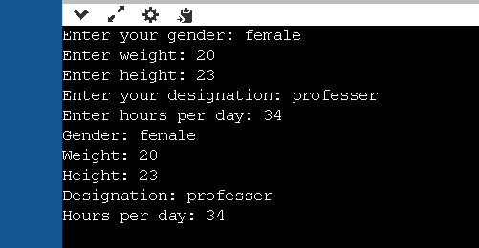

Task 2:  
Create Class Person with variables weight,height, gender and functions walk() sit(). Ceate another Class Sudent with variable ID,First name, Last name, Graduation and function PrintDetail() Write(). Now create a class GraduationStudent with variables UniversityName, YearGraduation and functions Display().

Note: In both parent classes simply add a printf() statement about the task. In child display function show all data

|  |
| --- |
| #include <iostream>  #include <string>  using namespace std;  class Person  {  protected:      string gender;      double weight;      double height;  public:      Person()      {          cout << "Enter your gender: ";          getline(cin, gender);          cout << "Enter weight: ";          cin >> weight;          cout << "Enter height: ";          cin >> height;          cin.ignore();      }      void walk()      {          cout << "He can Walk." << endl;      }      void sit()      {          cout << "He can Sit" << endl;      }  };  class Student : public Person  {  protected:      string firstName;      string lastName;      int id;      string graduation;  public:      Student() {}      void printdetails()      {          cout << "First name: " << firstName << endl;          cout << "Last name: " << lastName << endl;          cout << "ID: " << id << endl;          cout << "Graduation: " << graduation << endl;      }      void write()      {          cout << "Enter first name: ";          getline(cin, firstName);          cout << "Enter last name: ";          getline(cin, lastName);          cout << "Enter ID: ";          cin >> id;          cin.ignore();          cout << "Enter Graduation: ";          getline(cin, graduation);      }  };  class GraduationStudent : public Student  {  protected:      string yearGraduation;  public:      GraduationStudent() {}      void inputYearGraduation()      {          cout << "Enter Year of Graduation: ";          getline(cin, yearGraduation);      }      void display()      {          cout << "Gender: " << gender << endl;          cout << "Weight: " << weight << endl;          cout << "Height: " << height << endl;          cout << "First name: " << firstName << endl;          cout << "Last name: " << lastName << endl;          cout << "ID: " << id << endl;          cout << "Graduation: " << graduation << endl;          cout << "Year of Graduation: " << yearGraduation << endl;      }  };  int main()  {      GraduationStudent s1;      s1.inputYearGraduation();      s1.write();      s1.display();      return 0;  } |

Output

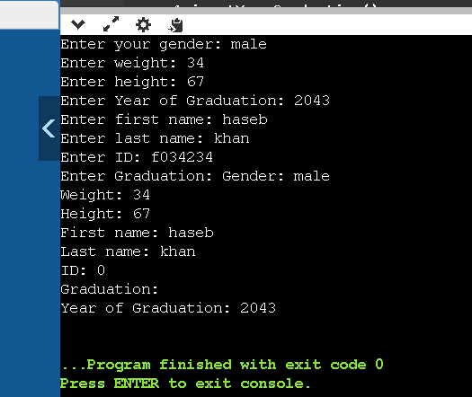

**Task 3:**

Create Class Date with variables day,month,year and a function display() and another class Time with variables hour,minutes,seconds and a function display(). Now create a third class named Time_Date it will inherit from both Classes Date and Time it should have a function display() which will display time and date.

|  |
| --- |
| // Create Class Date with variables day,month,year and a function display() and  // another class Time with variables hour,minutes,seconds and a function display().  //  Now create a third class named Time_Date it will inherit from both Classes Date and  //  Time it should have a function display() which will display time and date.  #include <iostream>  using namespace std;  class Date  {  protected:      int day, month, year;  public:      Date(int d, int m, int y) : day(d), month(m), year(y) {}      void display()      {          cout << "Date: " << day << " " << month << " " << year << endl;      }  };  class Time : public Date  {  protected:      int hour, mint, sec;  public:      Time(int h, int mi, int s, int d, int m, int y) : hour(h), mint(mi), sec(s), Date(d, m, y) {}      void display()      {          Date::display();          cout << "Time: " << hour << " " << mint << " " << sec << endl;      }  };  class Time_Date : public Time  {  public:      Time_Date(int hour, int mint, int sec, int day, int month, int year) : Time(hour, mint, sec, day, month, year) {}  };  int main()  {      Time_Date i(3, 32, 34, 12, 4, 2024);      i.display();      return 0;  } |

Output

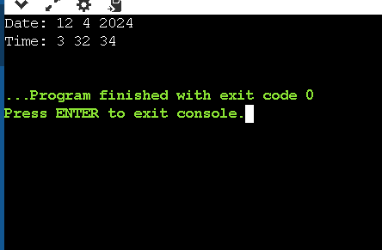

Task 4:

Create class named shape with variables height and width. Create another class named color with variable color_name. Now create third class named Rectangle with variable area. Inherit rectangle class from shape class and color class. Now calculate area of rectangle and define color of rectangle as well.

|  |
| --- |
| // Create class named shape with variables height and width.  // Create another class named color with variable color_name.  // Now create third class named Rectangle with variable area.  // Inherit rectangle class from shape class and color class.  // Now calculate area of rectangle and define color of rectangle as well.  #include <iostream>  using namespace std;  class Shape  {  protected:      double height, width;  public:      Shape() {}      Shape(double h, double w) : height(h), width(w) {}      ~Shape() {}  };  class Color : public Shape  {  protected:      string color_name;  public:      Color() {}      Color(string n, double h, double w) : color_name(n), Shape(h, w) {}      ~Color() {}  };  class Rectangle : public Color  {  protected:      double area;  public:      Rectangle() {}      Rectangle(string n, double h, double w) : Color(n, h, w) {}      void cal_rect()      {          cout << "Color: " << color_name << endl;          area = height * width;          cout << "Area: " << area << endl;      }      ~Rectangle() {}  };  int main()  {      Rectangle a;      Rectangle b("red", 20, 47);      b.cal_rect();      return 0;  } |

Output:

